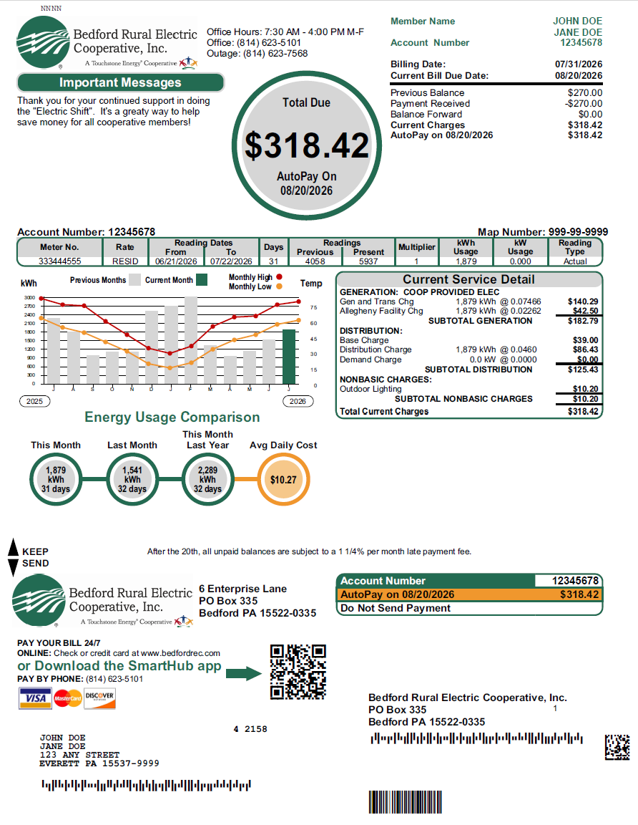
Beginning November 2026, you will notice a new look to your Electric billing statement.
2

Follow the numbers below as a guide to reading your new billing format.
44

1
3
      - Amount due on account.
      - Your account number. Please refer to this number when calling in or making payments.
      - Billing Summary shows activity since last billing.
5
      - Message Center for important messages from BREC.
      - Meter number and meter reading information.
      - In the graph you can see monthly energy usage comparison along with monthly high and low temperatures. You can compare your current usage (kWh) with the previous year. The current month is the green bar on the right with the grey bars being the previous 12 months.
6
7

      - Current details of charges for electric use.
      - Account number and amount due. Return stub with your check or cash payment.
      - New ways to pay online and on our SmartHub app. We accept Mastercard, Visa, and Discover.
8

On the reverse side of the bill, you will find helpful tips for power outages, contact information, past due bills and payment options. You will see at the bottom of the page a place for updating personal information.
9

To go paperless, please visit us at www.bedfordrec.com and sign up for SmartHub. SmartHub is a fast and convenient way to make your payment and view usage history.

Sample

